

# Task 2 – Pass Submission

Student Number: 104071453  
Student Name: Marco Giacoppo

Pass 2a

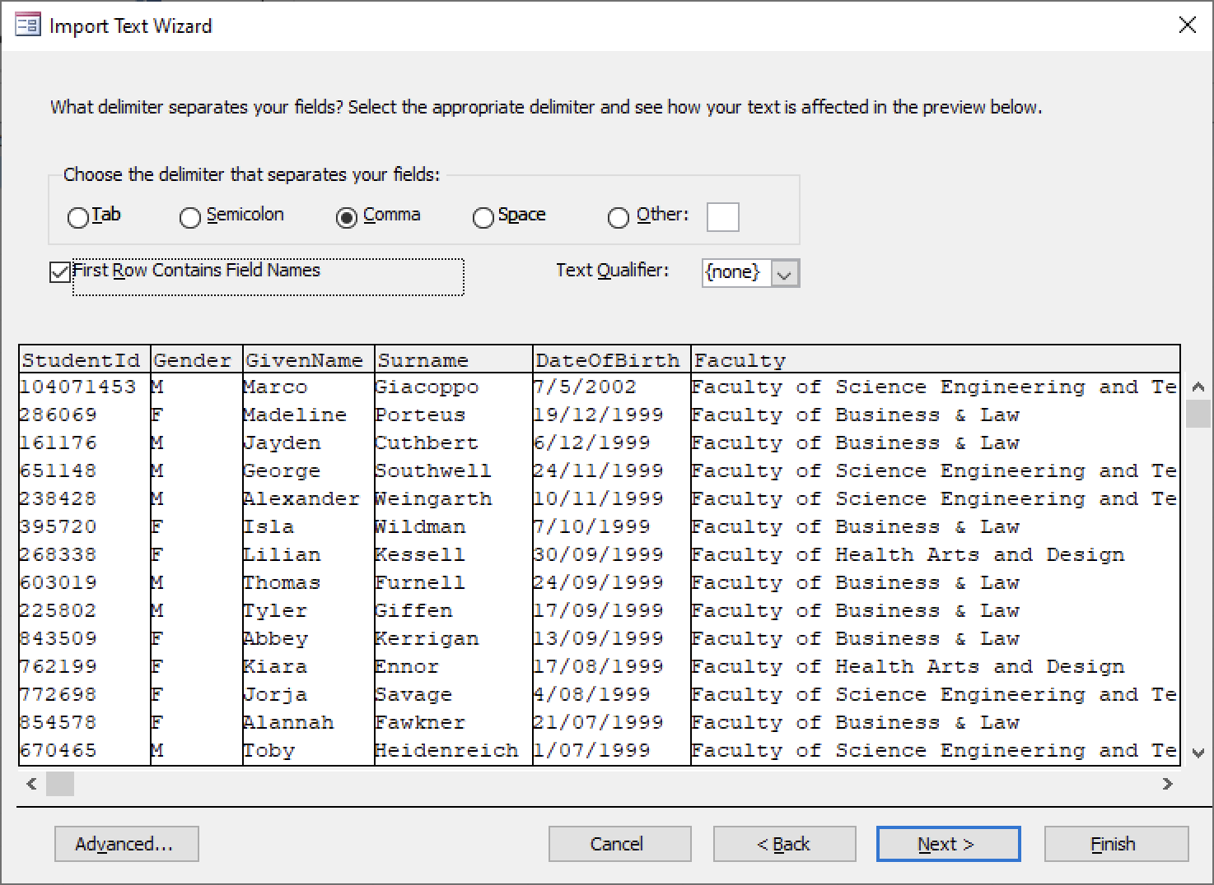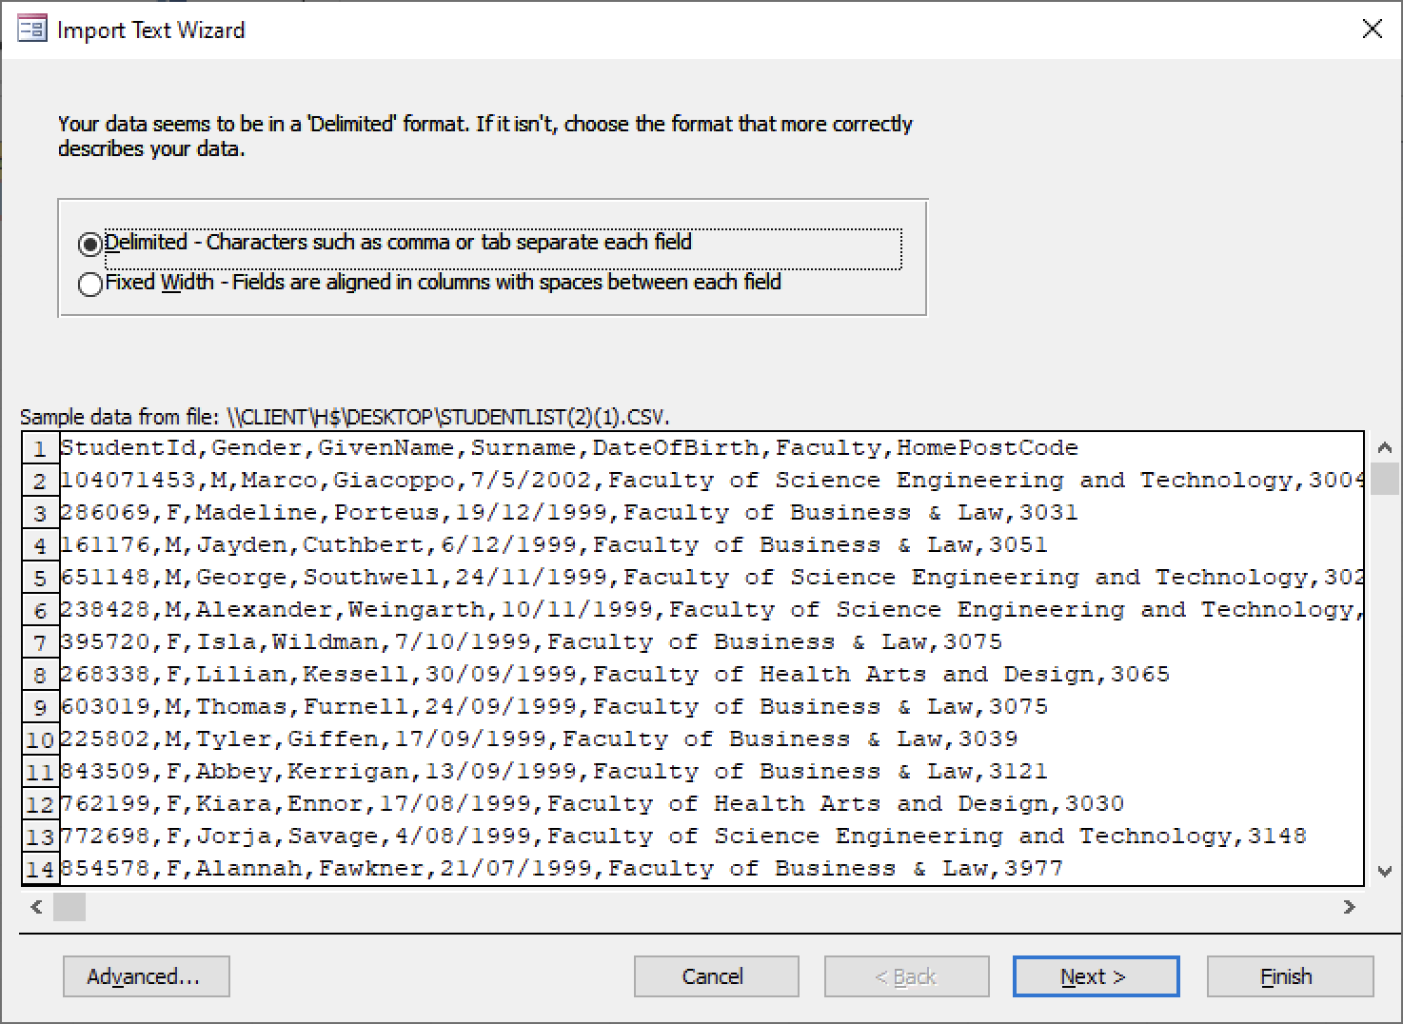

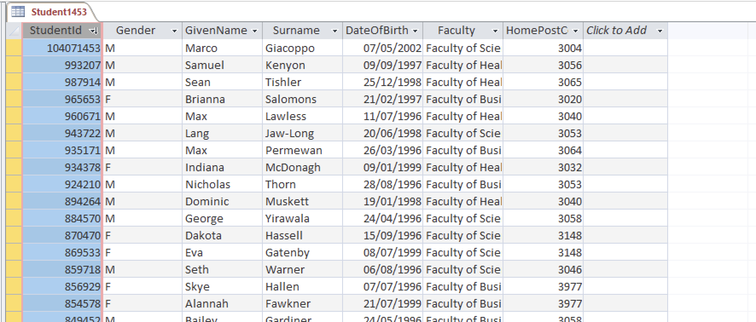

### Pass 2b

Why does double clicking typically cause a csv file (*such as student.csv) to open in Excel rather than Notepad? Because when we install Microsoft Excel, it often sets itself as the default program for opening CSV files and because Microsoft will open any file with their app if it’s possible.

What steps can you take to ensure that when you double click a .csv file it will cause Notepad.Exe to open that file (instead of Excel)? We could right-click on the file and choose “Open with”. Then we can choose our desired app, which is Notepad, then before clicking “OK” or “Open”, we can check the box that says ‘Always use this app to open .csv files’. This will ensure that the .csv files are associated with Notepad.

### Pass 2c

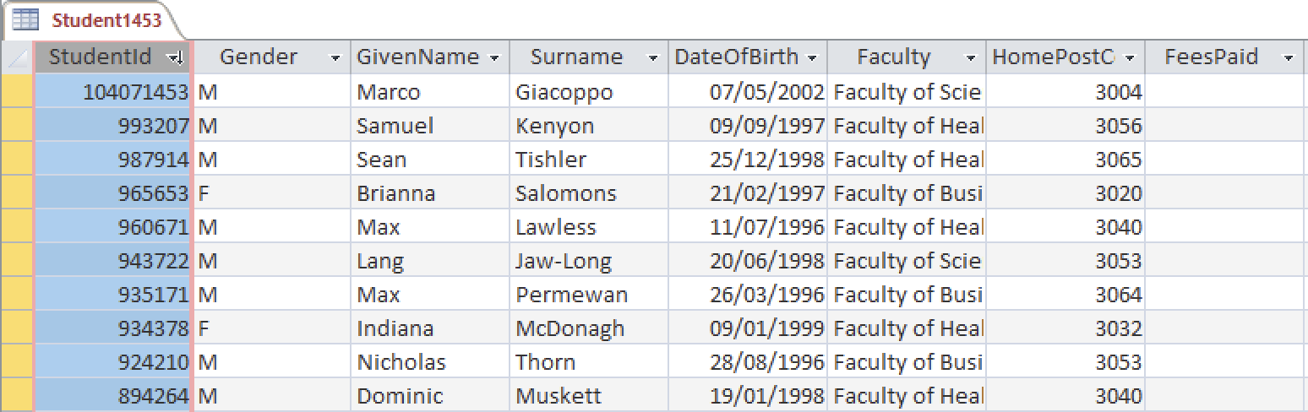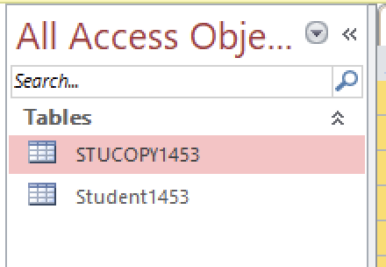

### Pass 2d

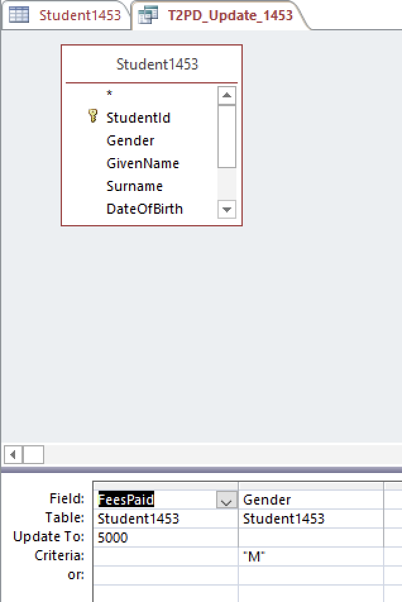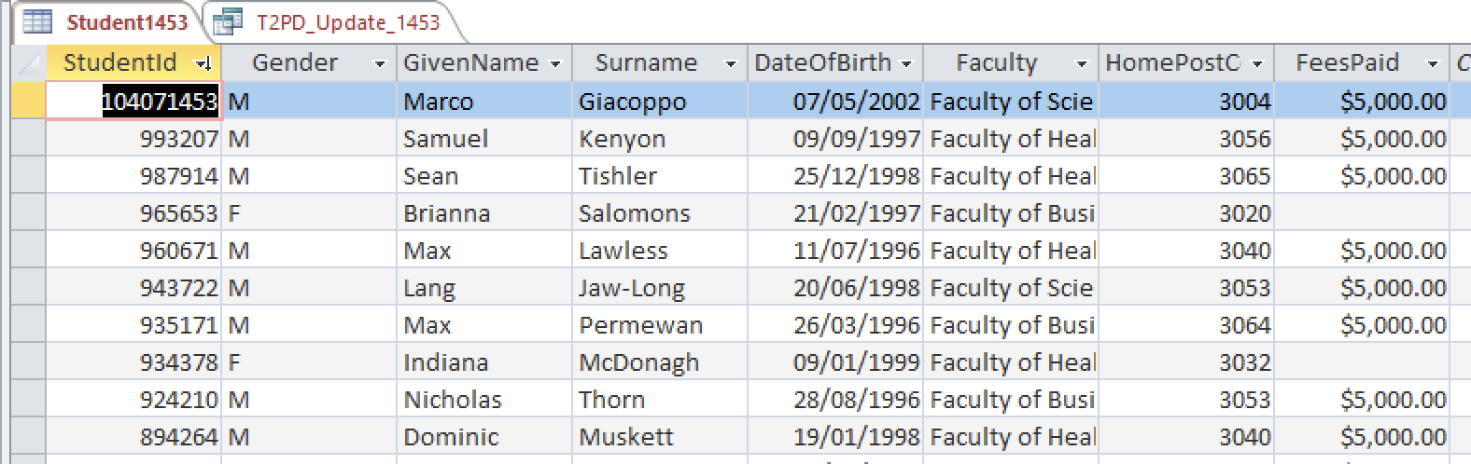

### Pass 2e

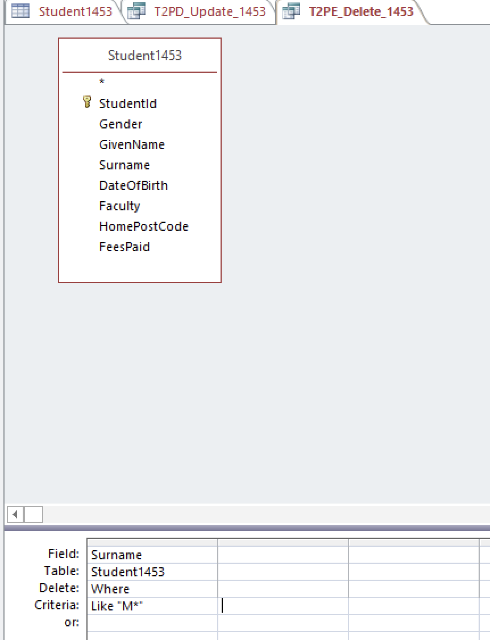

### Pass 2f

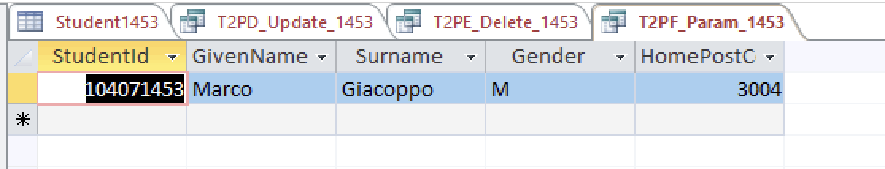

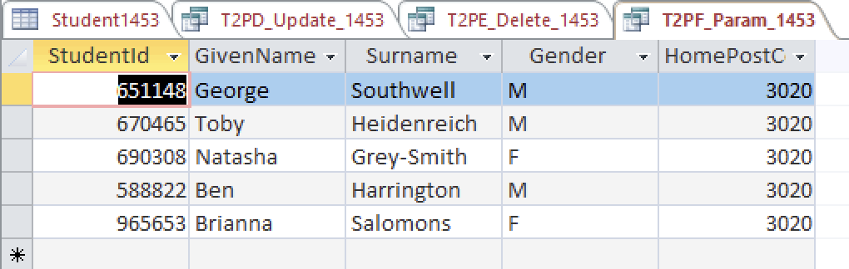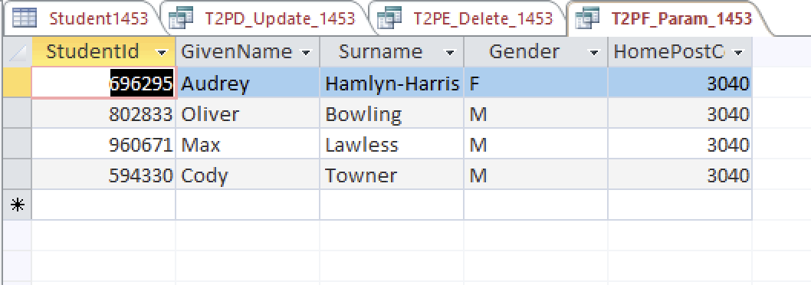

### Pass 2g

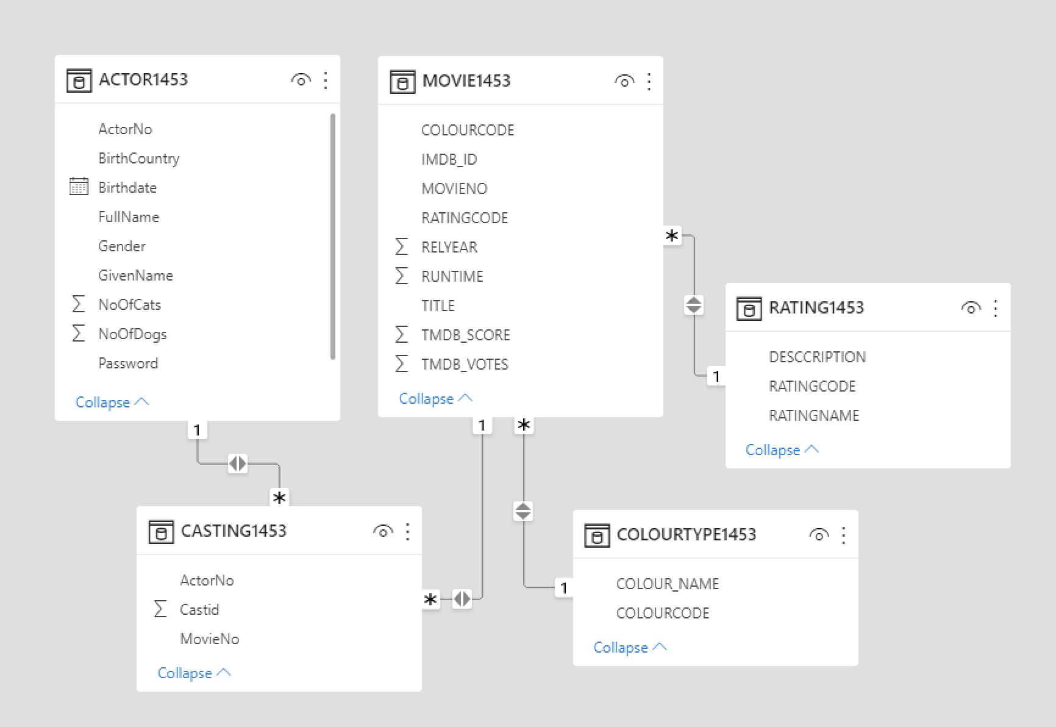

### Pass 2h

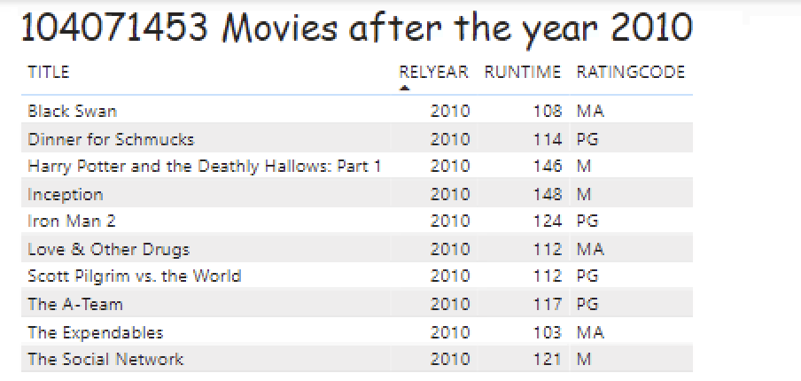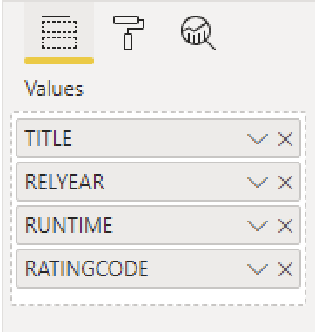

### Pass 2i

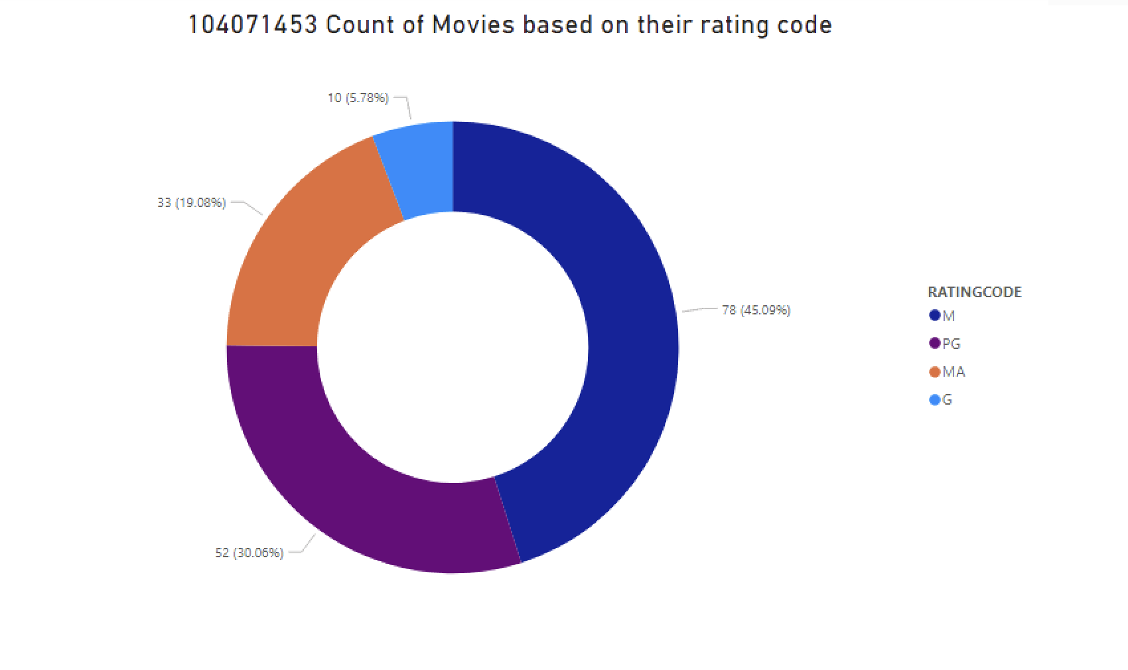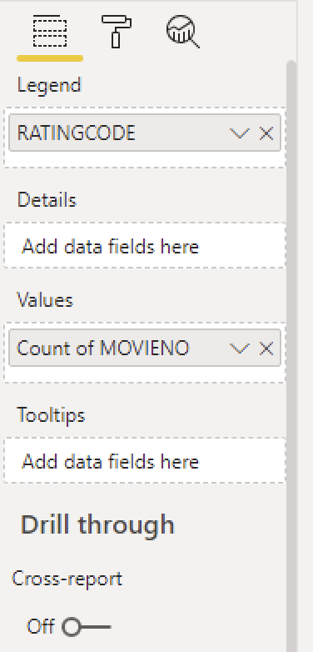

### Pass 2j

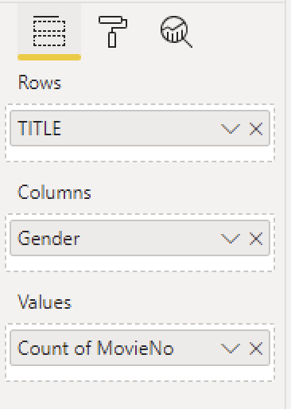

### Pass 2k

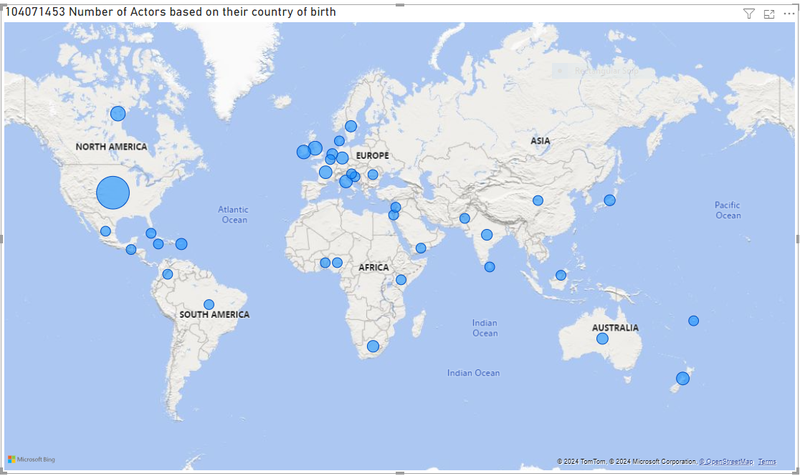

### Pass 2l

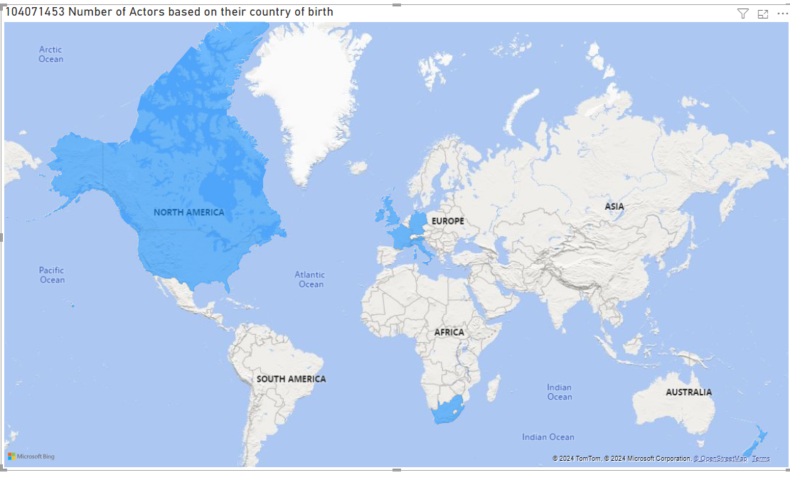

### Pass 2m

